Information support for research development of turbulence and the formation of solitons
Yu.I. Molorodov
Institute computational technology SB RAS
e-mail address: yumo@ict.sbras.ru
An important task of information management research in the field of modern physics is to organize regular discussions of the results obtained by different research groups in Russia and foreign teams. Subjects of research covers fundamental topics in modern physics - Nonlinear wave processes and turbulent phenomena in dispersive media. It is important to understand the physics of the formation of solitons, the occurrence of collapse and the formation of turbulence. It is important to assess the achievements, to see trends and to predict the prospects of this area of knowledge.
That is the purpose of pursuing a workshop on "Solitons, Collapses and Turbulence: Achievements, Trends and Prospects", which will be held in Novosibirsk from 4 to June 8, 2012
This event is preceded by a large amount of preparatory work performed by the organizers associated with ensuring the normal course of various processes at all stages. The first step is to initiate the conference formulated goals and objectives, designated subjects, determined by time and place, formed working committees to ensure the execution of various works. The competence of the program committee is to identify meaningful content of the conference, the specifics of those discussions and reports submitted. The Organizing Committee is the focal point of the conference and engaged in the resolution of issues outside the scope of the program committee. These committees provide a total fulfillment of the tasks and are responsible for the success of the conference.
The second phase is a notification to all potentially interested individuals and organizations about the fact of the conference and related parts: subject, date and venue, the conditions of participation. To do this, the organizers of this information is placed on electronic bulletin boards devoted to relevant topics. An important role at this stage is the availability of information, so that by the beginning of the second phase of the organizers create an Internet site, which is published and updated promptly all necessary information, and his email address (in our case http://conf.nsc.ru/en/page / sct2012) appears on all ads and letters.
In the next stage the organizers begin to analyze the incoming information. From the stream of letters and phone calls on various organizational issues, and suggestions, are two constant components: an application to participate in the conference and abstracts of reports submitted. With the help of the organizers of applications make qualitative and quantitative preliminary assessments of the participants and clarify the plan during the conference. Submitted abstracts are required for the diversion of each report rightful place in the program of meetings.
At the beginning of the fourth stage, after a pre-appointed time, the organizers stop receiving abstracts and proceed to their analysis. Program Committee, consisting of experts, the report evaluated on several criteria: originality of the topic, the availability of presentation, relevance of the work, and others. Often, within the overall theme of the conference examines several different themes, with presentations on different topics are presented and discussed separately. The competence of the program committee is reviewing the report, when the line is checked and the profile of the conference, and a comparison of his particular subject area. As a result of a review of the reports shall be drawn up and out of the conference program. At the end of the fourth and last stage of the forming of the preparatory program of meetings and plan all activities, which are published on the conference website, and get ready to print collections of theses, which are issued by the conference participants at registration.
An important part of the conference is to register the arriving participants. The organizers should be aware in advance of their intention to stay in hotels of a class and provide the opportunity. At this stage it may be a number of other problems, some of which it is desirable to prevent the preparatory stages, to settle the rest of the conference organizers should also be prepared.
After completion of the main stage, on its final part, the organizers summarize the conference, reporting write articles on the results of the conference. Often, published a collection of the most interesting reports to make conference materials available in the future.
It is important to note that the success of the conference depends on the success of each stage. Therefore, the organizers of the conference requires software tools that can improve their performance at each step and automate the process of the whole. Conference - events which are of regular nature, and create these tools each time is impractical. Therefore, the tools must be able to adjust to the specifics of a particular event. Another important aspect - the creation of a single information space for all the conferences, which would have implemented a flexible search. Common information space enables the use of new materials have already held conferences, for example, lists of participants for re-invitation.
The software tool must also have an automatic means of publication on the Internet all the necessary information about the conference, which includes: general information about the conference (topics, dates, venue, contact details, etc.), list of participants and a list of reports, equipped with search tools, conference program, full-text reports. Additionally, you need to provide means of communication and exchange of data with various external information systems - directory of publications, databases, external staff and organizations.
Many years of experience of conferences allowed to accumulate in the Information System "Conference" [1, 2], almost all the tools necessary to the organizers of such events for the fruitful and efficient operation. The system has been in existence for over seven years and now it contains information on more than 70 conferences held in 15 institutes of the Novosibirsk Scientific Center, as well as in Krasnoyarsk, Yekaterinburg, Irkutsk, in Kazakhstan.

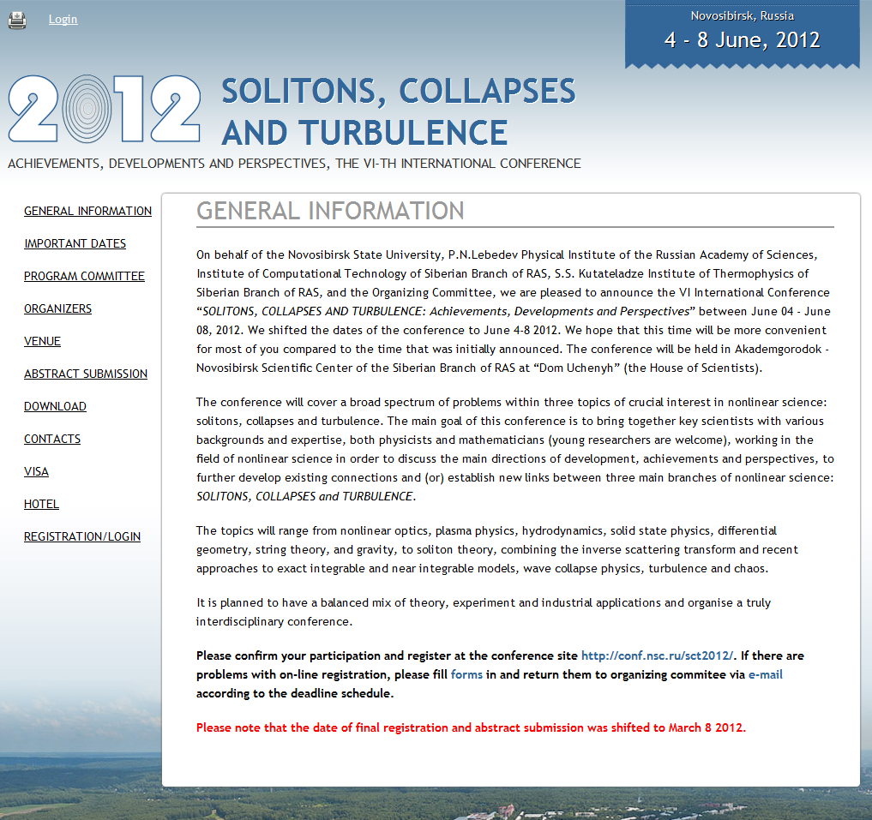

References
[1] Федотов А.М., Гуськов А.Е., Молородов Ю.И. “Информационная система конференция”.[http://www/sbras.ru/ws/]
[2] Гуськов А. “Semantic Web: теория и практика”. LAP LAMBERT Academic Publishing, 2005, p. 90

