SIBIRIAN DIVISION OF

RUSSIAN ACADEMY OF SCIENCES

LAVRENTYEV INSTITUTE OF HYDRODYNAMICS

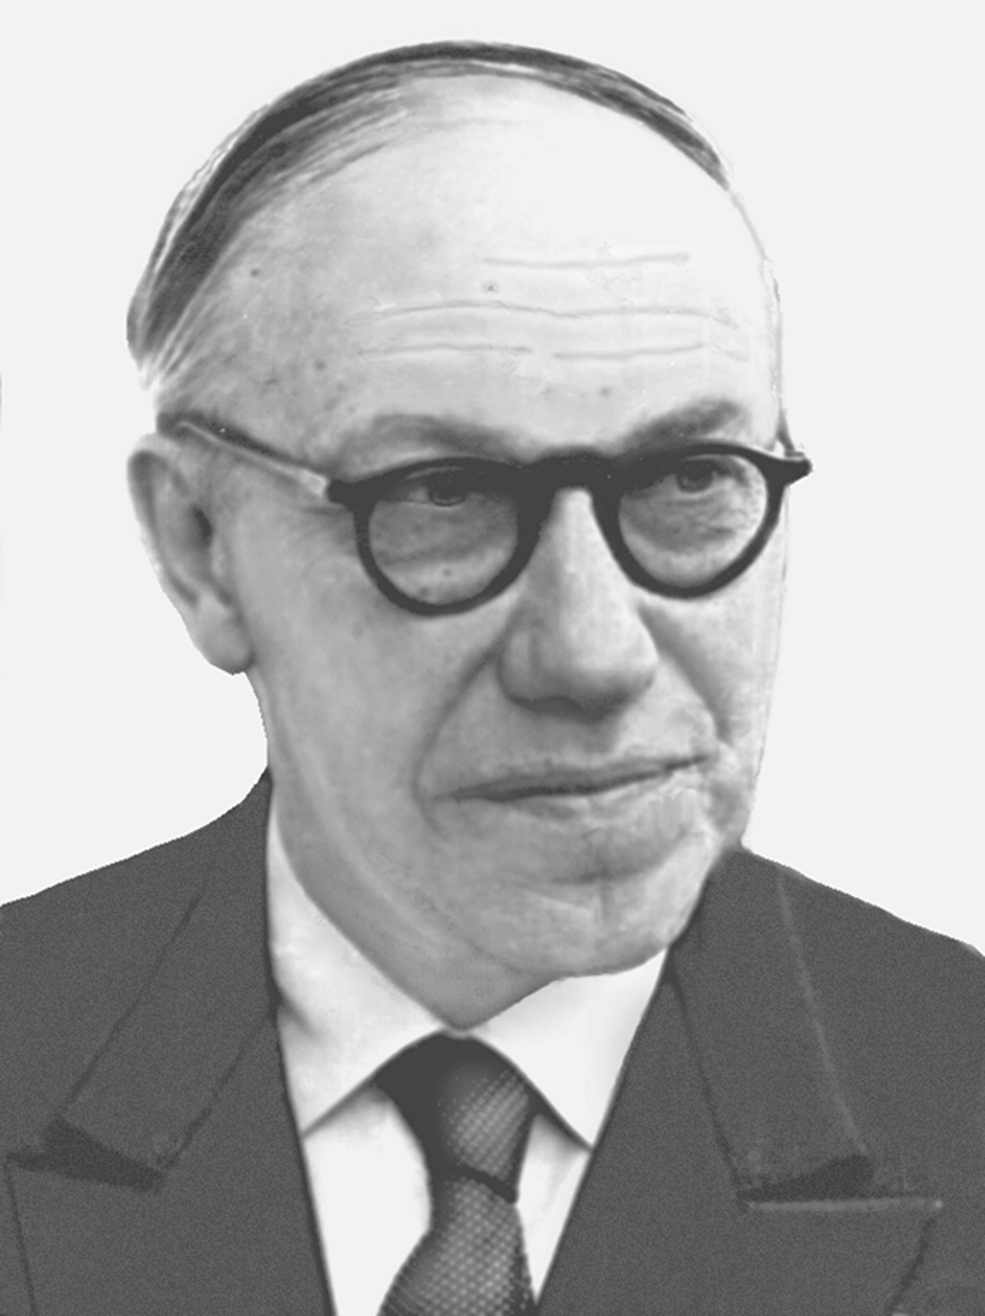

VII INTERNATIONAL CONFERENCE
dedicated to the 110-th anniversary of

academician M.A. Lavrentyev

" LAVRENTYEV READINGS ON MATHEMATICS, MECHANICS and PHYSICS "

August 23-27, 2010
Novosibirsk, Russia
FIRST ANNOUNCEMENT

PROGRAM COMMITTEE
- Academician V.M. Titov, Co-Chairman
- Prof. A.P. Chupakhin
- Prof. E.B. Ermanyuk
- Ph D. E.R. Pruuel secretary
- Prof. V.K. Andreev
- Corr. member of RAS B.D. Annin
- Prof. S.L. Gavrilyuk
- Academician S.K. Godunov
- Corr. member of RAS G.I. Kanel’ (Москва)
- Prof. V.K. Kedrinskii
- Prof. A.N. Kraiko
- Academician A.G. Kulikovskii
- Prof. V.F. Kuropatenko
- Academician M.M. Lavrentyev
- Academician V.A. Levin
- Prof. I.I. Lipatov
- Prof. B.G. Loboiko
- Prof. A.L. Mihailov
- Corr. Member of RAS V. Ya. Nailand
- Academician L.V. Ovsyannikov (Новосибирск)
- Corr. Member of RAS Yu. N. Pavlovskii
- Corr. Member of RAS P.I. Plotnikov
- Corr. Member of RAS V.V. Puhnachev
- Academician A.K. Rebrov
- Corr. Member of RAS S.T. Surzhikov
- Prof. M.E. Topchiyan
- Academician V.F. Fomin
- Prof. S.V. Habirov
- Prof. R.M. Shagaliev.

The 7th International Conference “Lavrentyev Readings on Mathematics, Mechanics and Physics” is dedicated to the 110th anniversary of the outstanding Russian scientist in the field of mathematics and mechanics, the founder of the Siberian Division of the Russian Academy of Sciences, academician M.A. Lavrentyev. Six preceding conferences took place in Novosibirsk (1982, 1990, 2000, 2005), Kiev (1985) and Kazan’ (1995). Scientific topics will cover the problems of mathematics, mechanics, physics, as well as their applications, where the fundamental contribution of M.A. Lavrentyev is the most valuable. Leading scientists will deliver keynote lectures on scientific topics of the Conference.

GENERAL AREAS

- Differential equations and theory of functions. Boundary problems, analytical functions, conformal and quasiconformal mappings.
- Mathematical problems of the continuum mechanics. Free boundary problems. Numerical experiment.
- Mechanics and physics of pulsed processes, including explosive ones. Behavior of materials and constructions under dynamic loading.

CALL FOR PAPERS

Selection of papers for presentation at the Conference will be based on the abstracts (300-500 words) which should be as informative as possible. The conference program will include original reports reflecting the present state in the above-mentioned scientific areas.
Authors should submit an abstract in English in an electronic form. Abstract submission guidelines can be found on the site of the Conference. The abstracts of all selected reports will be published in English and Russian in the Conference Book of Abstracts. The publication of the full papers is not planned.

KEY DATES

March 7, 2010 Abstracts Submission and Online Registration Deadline
April 5, 2010 Notification of Acceptance
August 23-27, 2010 Conference Dates

CONFERENCE VENUE

Conference will be held in the beautiful area of Novosibirsk situated on the Ob’ Sea in Akademgorodok where the world-known Novosibirsk Scientific Center is placed. All conference sessions will be held in the House of the Scientists. Working languages of the Conference are Russian and English.
Sightseeing tours to Novosibirsk and Akademgorodok are planned.

REGISTRATION FEE

The registration fee of 200 EUR should be paid in cash on arrival. We will not accept payments by credit cards or any other way of payment.

CORRESPONDENCE

Please address the abstracts, all technical correspondence and questions to:

Lavrentyev Readings - 2010
Conference Secretary, Pruuel Edward Reinovich
Lavrentyev Institute of Hydrodynamics
Lavrentyev Prospect 15, Novosibirsk
630090, Russia
Phone (383) 333 19 64, Fax (383) 333 16 12

E-mail: lavr@hydro.nsc.ru
URL: http://conf.nsc.ru/lavr10

